***Average salary of departments***

**Creating department table:**

create table department

(

dept_id int primary key,

dept_name varchar(20)

);

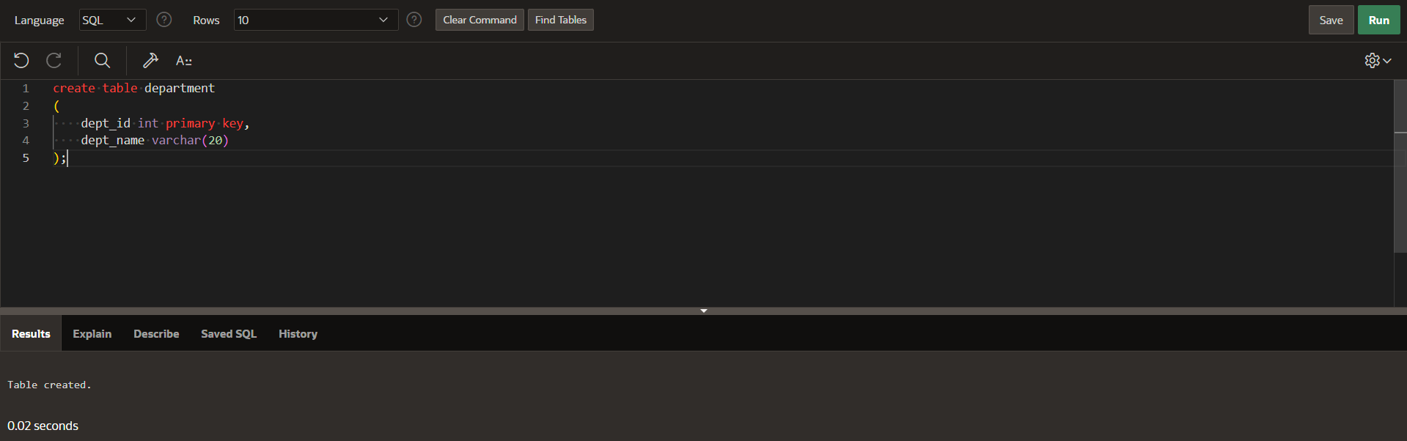

**Inserting into table:**

insert into department

values(10,'human resources');

insert into department

values(11,'IT');

insert into department

values(12,'finance');

insert into department

values(13,'legal'); 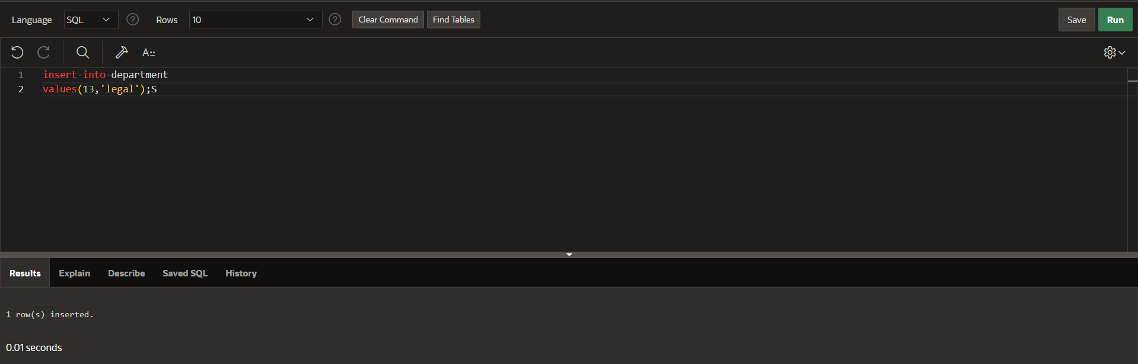

displaying department table:

select *from department;

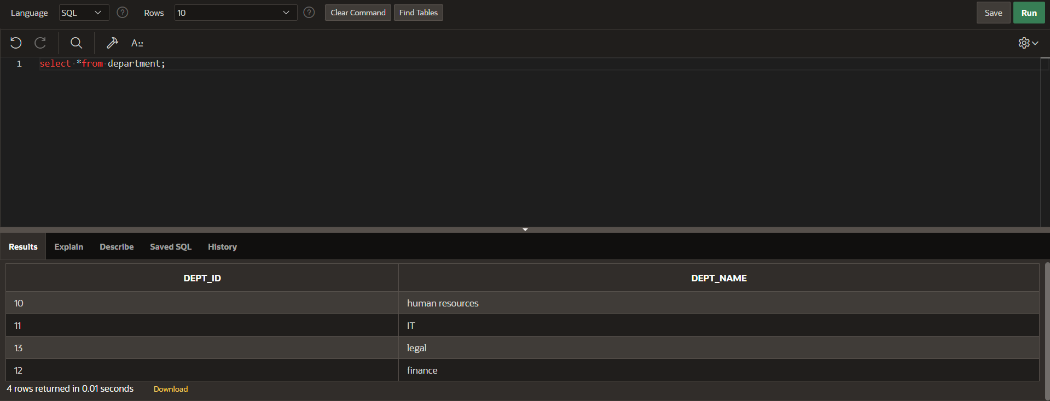

**Creating an employee table:**

create table emp(

emp_id int primary key,

emp_name varchar(20),

salary int,

dept_id int references department(dept_id)

)

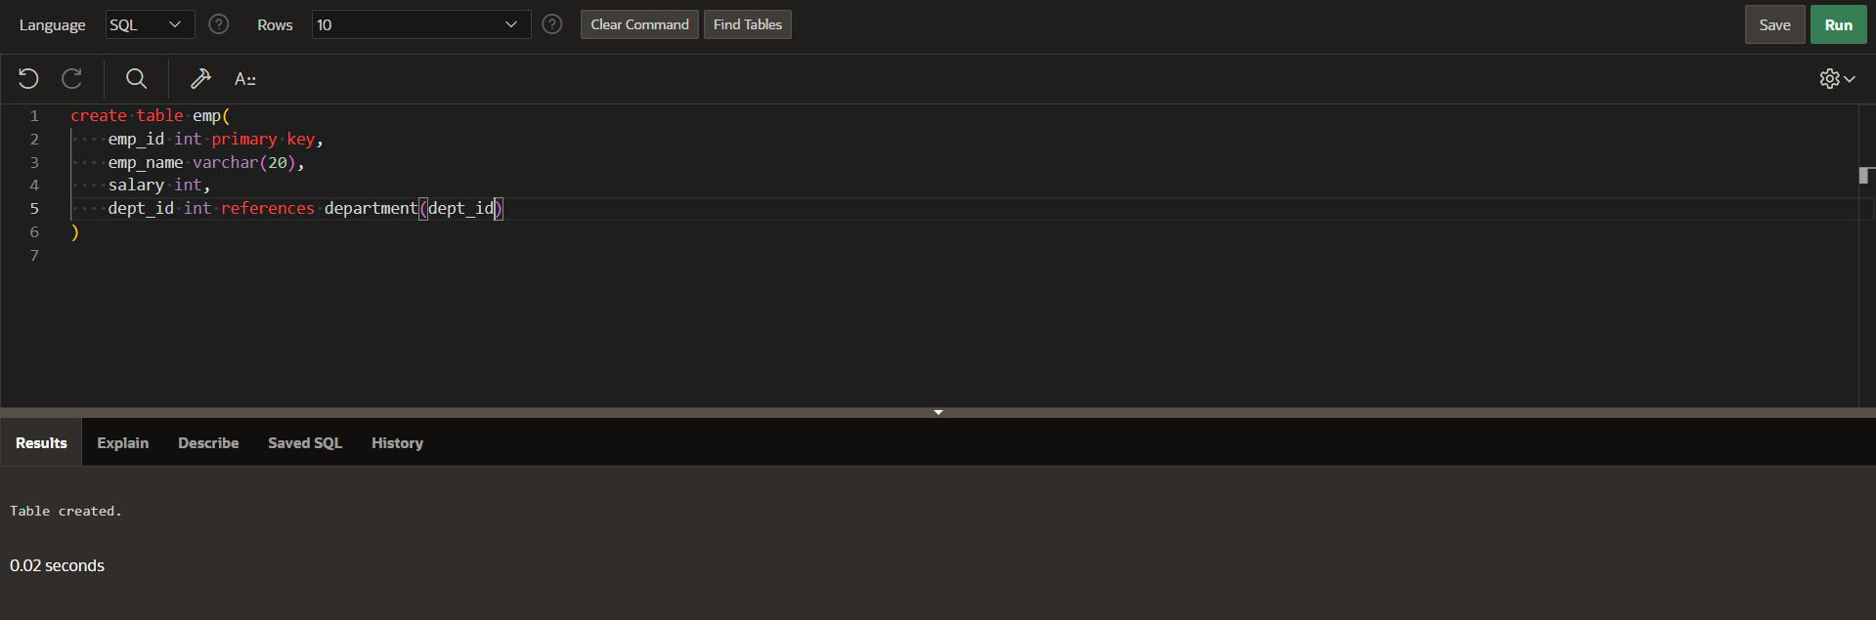

Inserting values into employee table:

insert into emp

values(1920,'rupesh',10000,11);

insert into emp

values(1921,'uday',15000,10);

insert into emp

values(1922,'harshit',13000,12);

insert into emp

values(1923,'haneesh',11000,10);

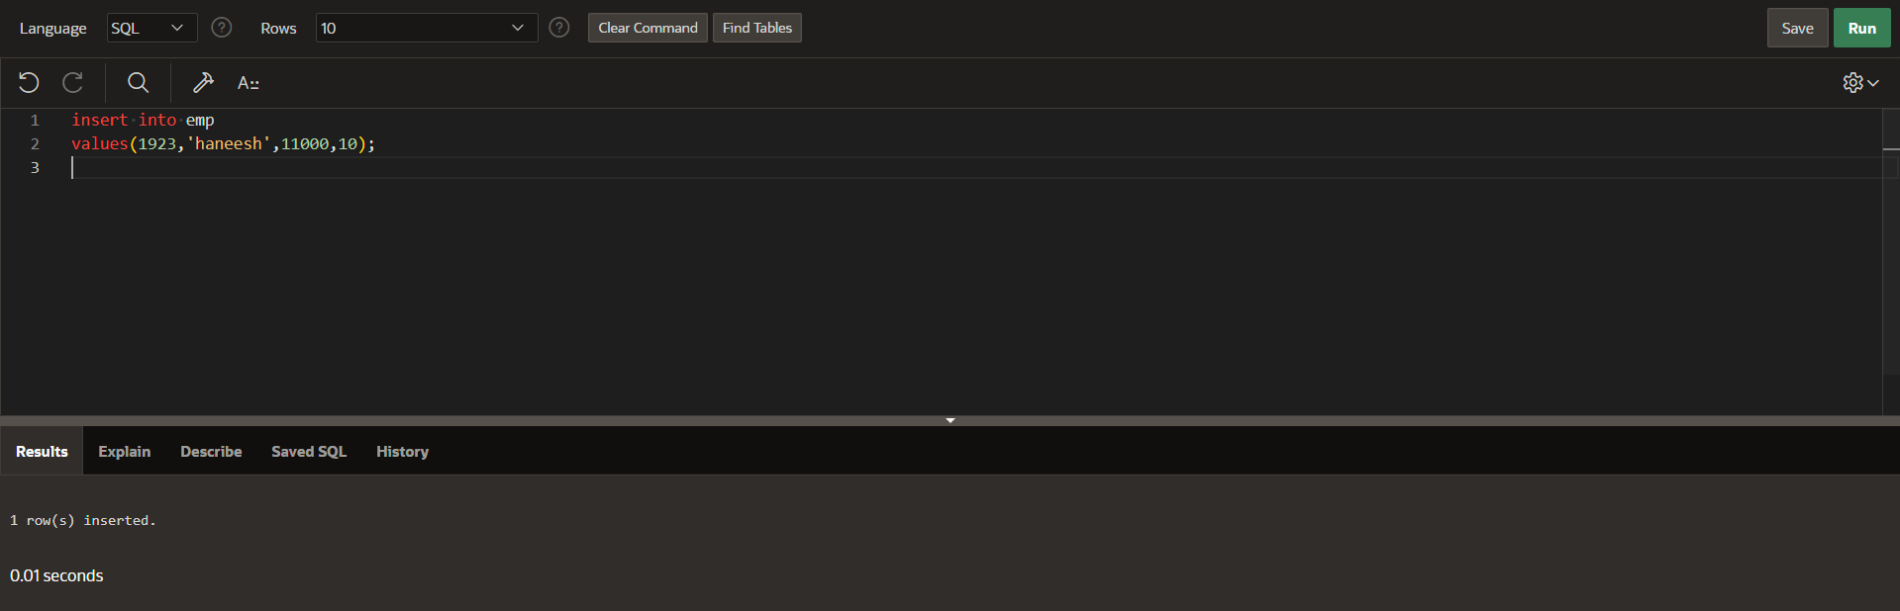

Displaying employee table:

select *from emp;

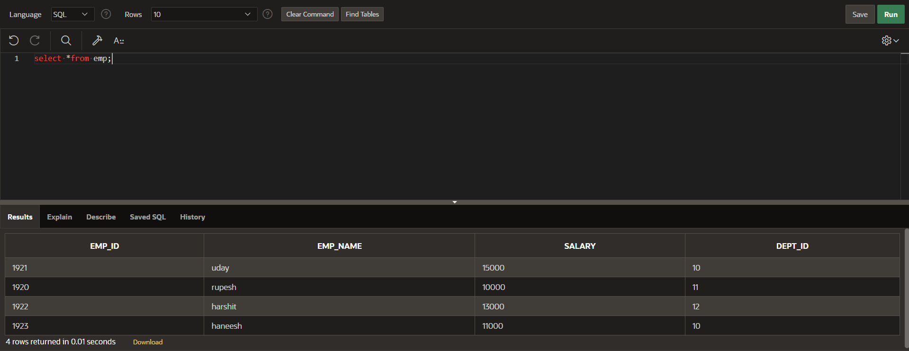

**Displaying the top 3 departments by average salary:**

SELECT d.dept_id, d.dept_name,

coalesce ((SELECT AVG(e.salary) FROM emp e WHERE e.dept_id = d.dept_id),0) As AvgSalary

FROM

department d

ORDER BY

AvgSalary DESC

fetch first 3 rows only;

